SEMESTER FEE REMINDER APP
@CREATIVITY THINK (9483175986/7019689991)

ABSTRACT:
Semester Fee Reminder App is a web-based application with a dashboard interface designed to help students and colleges manage fee structures, payment status, and reminders efficiently. The system allows students to view tuition, hostel, and exam fee details, track payment statuses, and receive timely notifications for pending dues. Administrators can create and edit fee structures, monitor student payments, send reminder notifications, and analyze collection data via a dashboard. Developed using Django and Django Rest Framework for backend processing and React with axios and chart.js for frontend interaction, the application ensures transparency, accuracy, and effective communication between students and administrators..

INTRODUCTION OF THE PROJECT:
Managing semester fees in educational institutions can be challenging due to scattered communication, missed payment deadlines, and lack of transparent tracking. Traditional methods like manual notices or emails are prone to delays and errors. The Semester Fee Reminder App addresses these issues by providing a centralized, interactive platform where students can track dues, receive reminders, and update payment statuses, while administrators can monitor collections, manage fee structures, and send automated notifications. This system enhances accountability, reduces missed payments, and ensures accurate semester-wise financial reporting..

PROJECT OBJECTIVES:

• Provide students with real-time visibility of fee structures (tuition, hostel, exam fees)
• Track payment status (Paid / Pending) for each student
• Send automated reminders to students for pending payments
• Allow administrators to create and edit fee structures efficiently
• Enable administrators to manage student payment records
• Provide dashboard analytics on paid/pending percentages and semester-wise collection
• Offer a user-friendly interface for both students and administrators
• Ensure secure and scalable backend API handling with Django & DRF

PROBLEM OF THE STATEMENT:
Students and colleges often face challenges in monitoring and managing semester fee collections. Delays in payment tracking, missed reminders, and lack of centralized records result in inefficiency and potential financial discrepancies. Traditional manual systems are error-prone and time-consuming. The Semester Fee Reminder App provides a streamlined digital solution that automates fee tracking, reminders, and analytics, improving efficiency, transparency, and accountability for both students and administrative staff..

MOTIVATION OF THE PROJECT:
• To digitalize fee management and reduce manual errors
• To ensure timely reminders for pending payments
• To enhance student awareness of due dates and payment status
• To provide administrators with an organized dashboard for collection monitoring
• To improve operational efficiency through automation
• To provide accurate semester-wise financial analytics
• To offer a user-friendly system accessible to students and administrators

BLOCK DAIGRAM OF PROJECT:

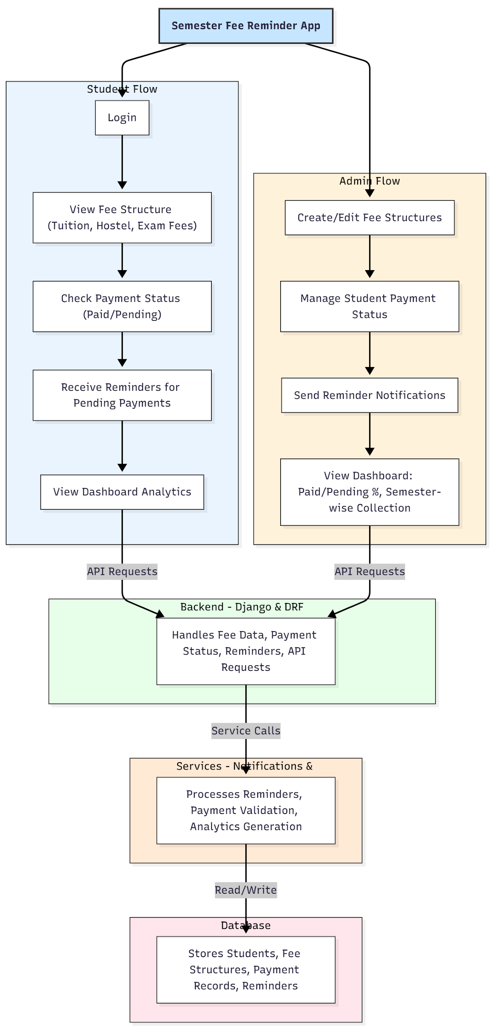

WORKING OF THE PROJECT:
Students log in to the system to view detailed fee structures, check payment status, and receive automated reminders for pending payments. Administrators create and edit fee structures, update student payment records, and send notifications for dues. The backend validates data, updates payment status, and generates analytics, which are displayed on dashboards for both students and administrators. The services module handles reminders and chart generation, while the database stores all structured data for fee management and tracking. This workflow ensures timely notifications, transparent records, and accurate semester-wise analytics..

SOFTWARE REQUIREMENT:
- Backend:
  - Python 3.x
  - Django
  - Django REST Framework
  - SQLite/PostgreSQL
- Frontend:
  - Node.js and npm
  - React.js
  - Axios
- Development Tools:
  - Visual Studio Code
  - Postman (for testing APIs)
  - Git/GitHub (for version control)
- Server/Deployment (Optional):
  - Gunicorn, Nginx, or Heroku/AWS for hosting

ADVANTAGES OF THE PROJECT:

• Transparent and real-time fee tracking
• Automated reminders reduce missed payments
• Dashboard analytics provide insight into semester-wise collection
• User-friendly interface for students and administrators
• Reduces administrative workload
• Secure and scalable backend APIs
• Centralized record of all student fee data
• Easy monitoring of paid/pending percentages

APPLICATIONS OF THE PROJECT:
• College fee management
• Student payment tracking
• Administrative dashboards for semester collections
• Automated reminder notifications
• Fee reporting and analytics for educational institutions

REFERENCES:

- Django REST Framework Documentation — Django Software Foundation. Django Documentation. Available: https://docs.djangoproject.com/
- Django REST Framework. DRF Documentation. Available: https://www.django-rest-framework.org/
- React. React Official Documentation. Available: https://reactjs.org/docs/getting-started.html
- Redux. Redux Documentation. Available: https://redux.js.org/introduction/getting-started
- PostgreSQL Global Development Group. PostgreSQL Documentation. Available: https://www.postgresql.org/docs/
- MySQL. MySQL Reference Manual. Available: https://dev.mysql.com/doc/
- Git. Git Documentation. Available: https://git-scm.com/doc
- Node.js. Node.js Documentation. Available: https://nodejs.org/en/docs/
- Axios. Axios Documentation. Available: https://axios-http.com/docs/intro
- Socket.io Documentation – https://socket.io/docs/

